**Year 10 History In-Class Source Analysis**

**Source Sheet (2023)**

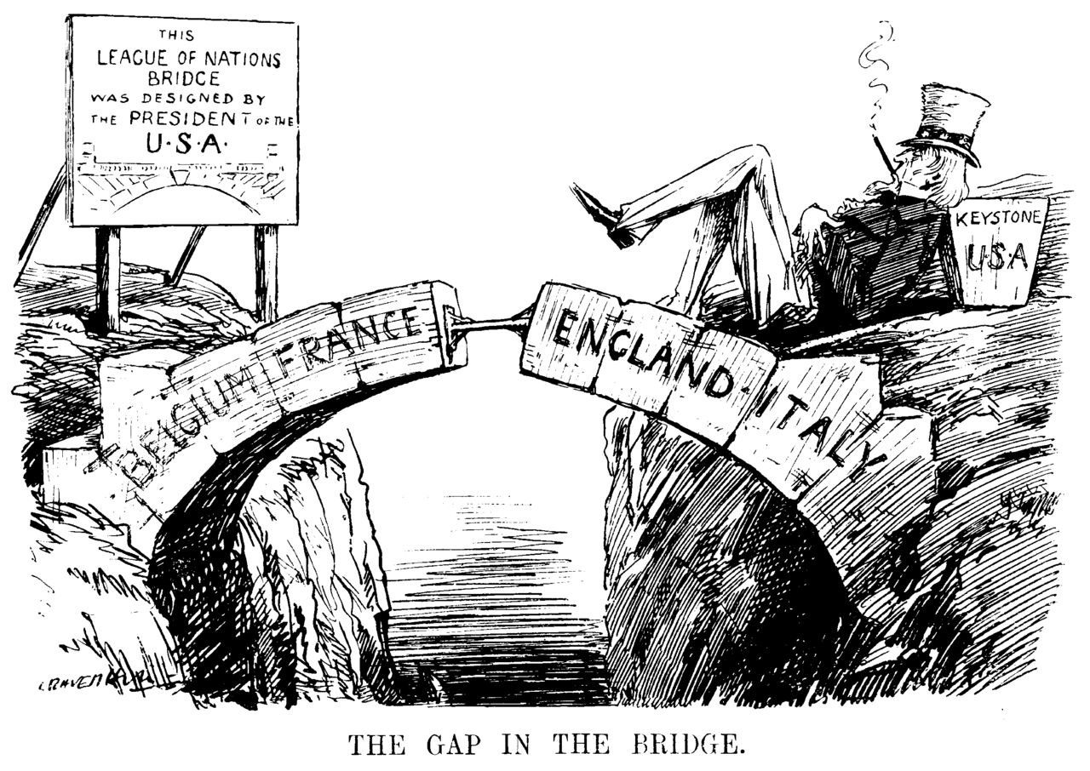**Source 1**:

‘*The Gap in the Bridge’*, published in 1919 in the British magazine ‘Punch’ by Leonard Ravenhill (10 December 1919)

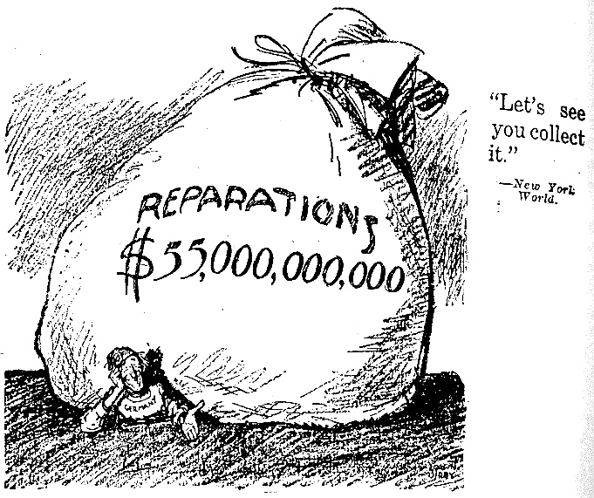**Source 2**:

An American cartoon commenting on the Treaty of Versailles, published by the New York World in 1921.

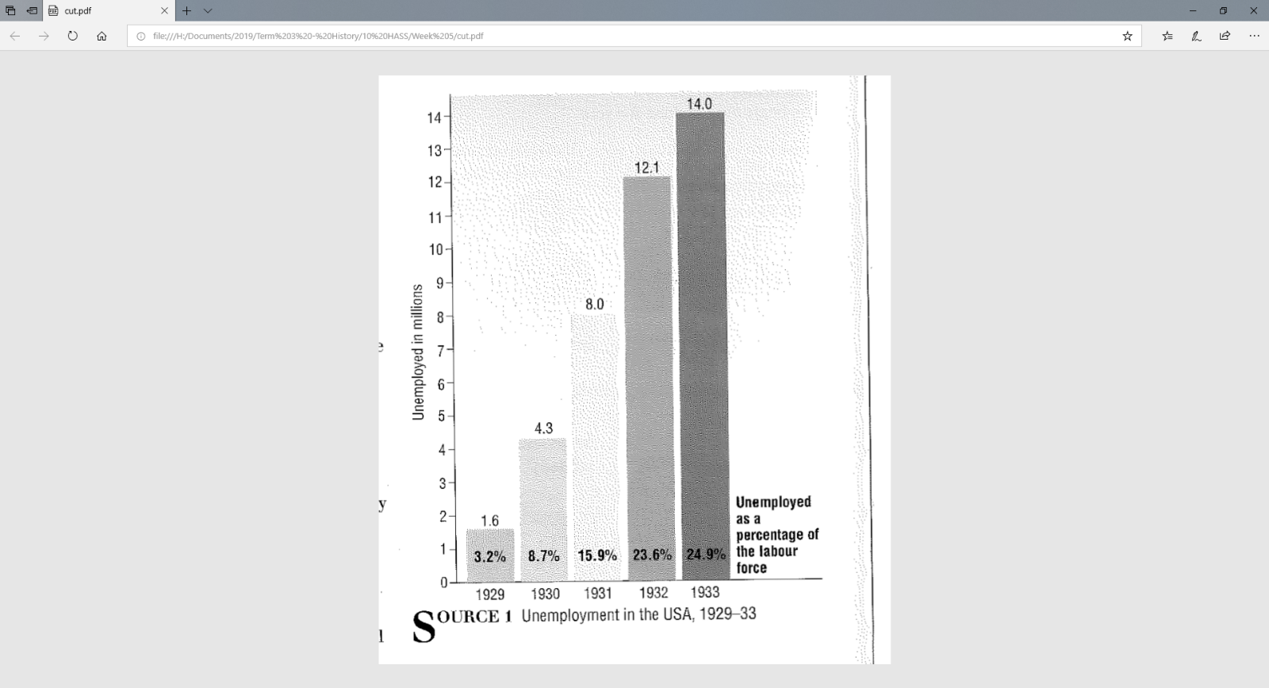

**Source 3:**

Unemployment in the USA, 1929-33,

created 1999.

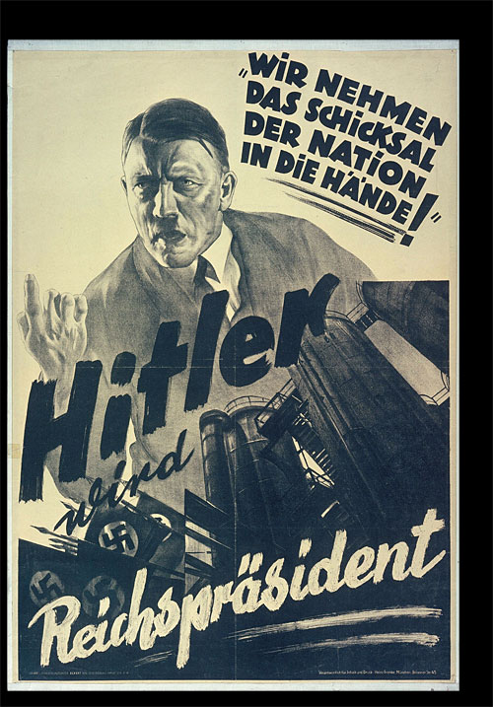**Source 4:**

Nazi propaganda poster created in 1932, just before the Nazi party won the largest number of seats in the Reichstag.

The text translates to ‘Hitler will become President’ and “We are taking the fate of the nation into our own hands”